Using attributes:

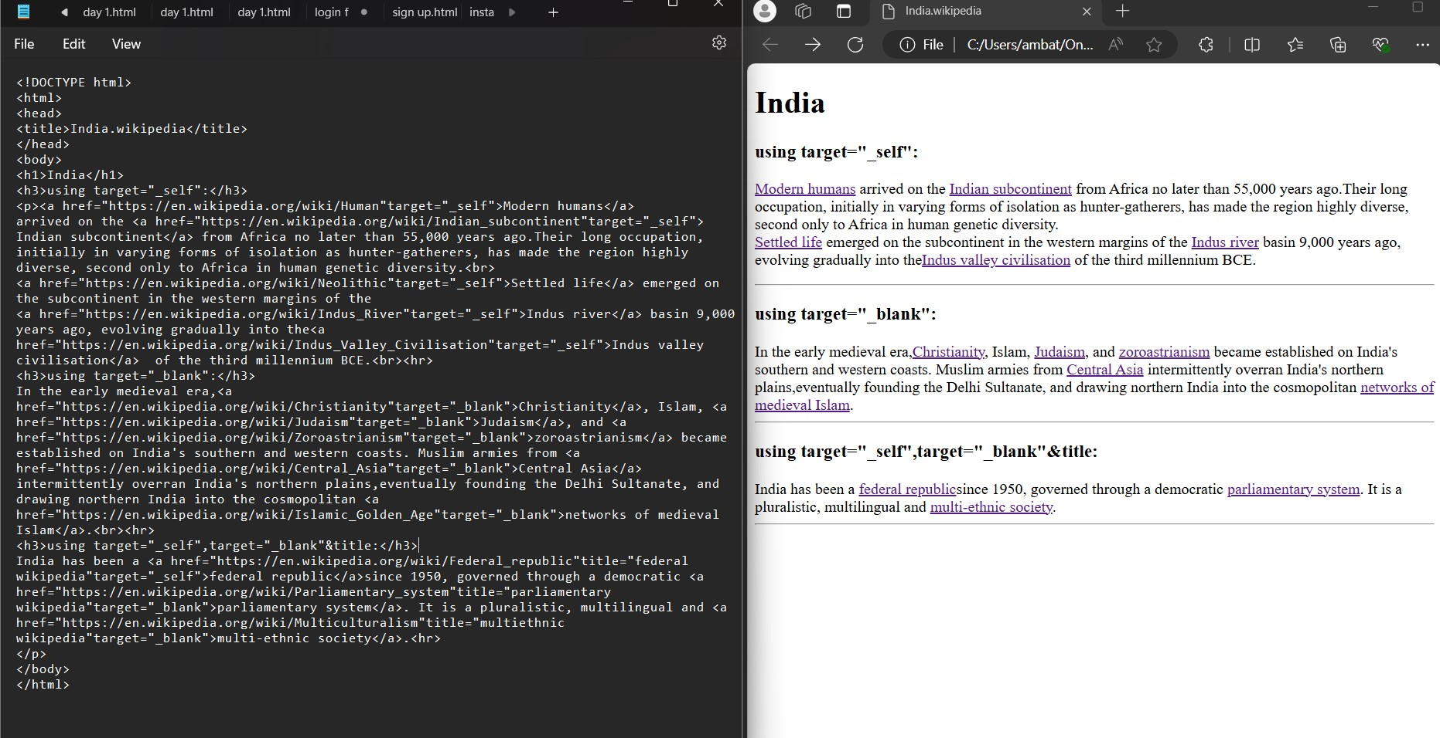

Html code:

<https://drive.google.com/file/d/1yp_UIJbZgirz5v3A_OeBiFkNIZqUEaQ4/view?usp=drive_link>